Big o cheatsheet with complexities chartBig o cheatsheet with complexities chart
Big o complete Graph
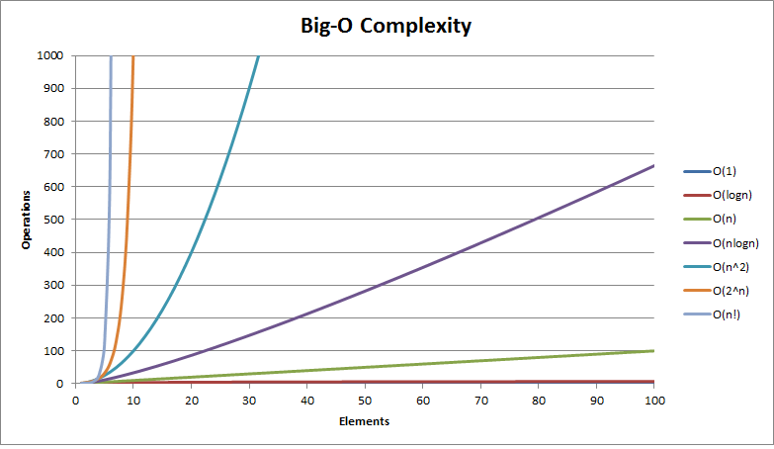
Legend
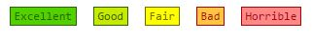
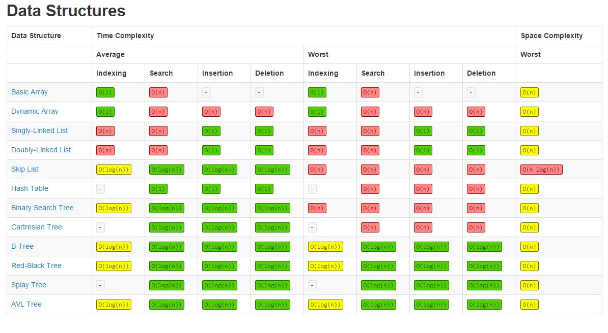
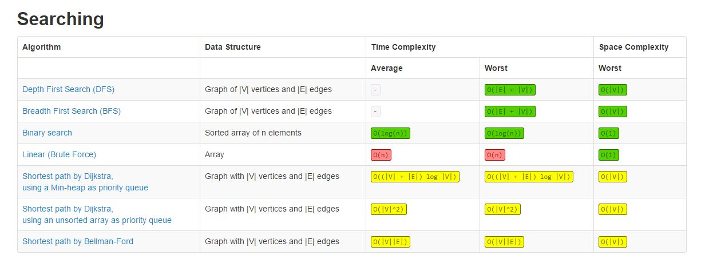
Sorting Algorithms chart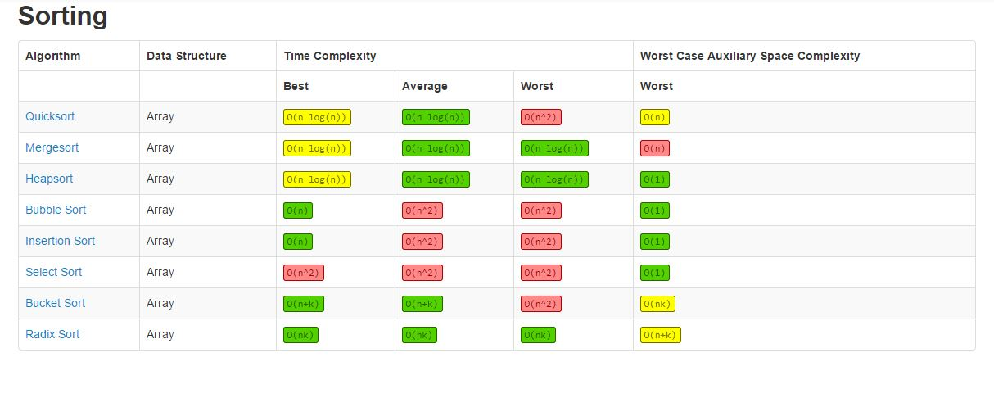
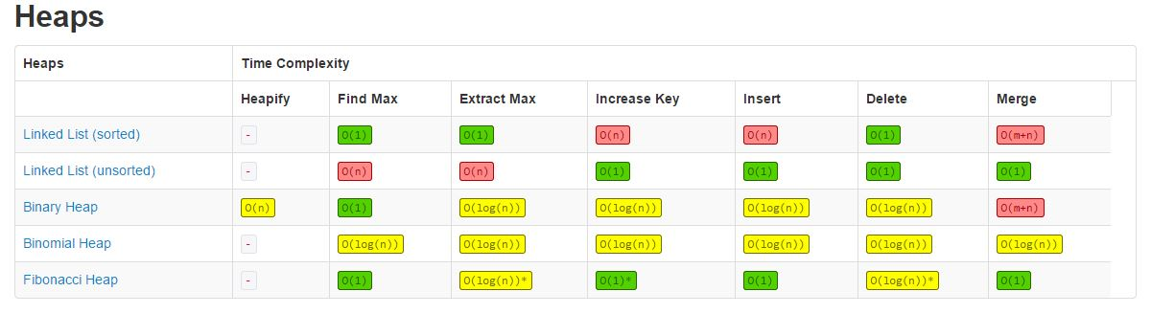Big o complete Graph
Legend
Sorting Algorithms chart

